Getting Started with Branding in SharePoint 2010
Lab Time: 30 minutes

Exercise 1: Connect to the Collaboration Site Collection
In this exercise you will access the Collaboration Site Collection in the browser to ensure you can access the sites where you will work on your lab exercises.
- Use the browser to navigate to the Collaboration Site Collection using the URL that was provided to you. Throughout these lab exercises, the student manual will refer to this URL as http://[[COLLAB-SITE]]. However, the URL that you will use is unique to you and will look something like this:
http://studentlabs.criticalpathtraining.com/sites/11062725-0COLLAB-BD9B6
- Once you navigate to the Collaboration Site Collection you will be prompted for login credentials. Enter the domain name and account name that was supplied to you by the site collection administrator. Throughout these lab exercises we will refer to your account name as [[AD_DOMAIN]]\[[USERNAME]].
- Once you have authenticated you should see the Collaboration Site Collection that will be used for the lab exercises of this course. When you navigate to the home page of the top-level site you should see a branded home page that looks like the following screenshot.
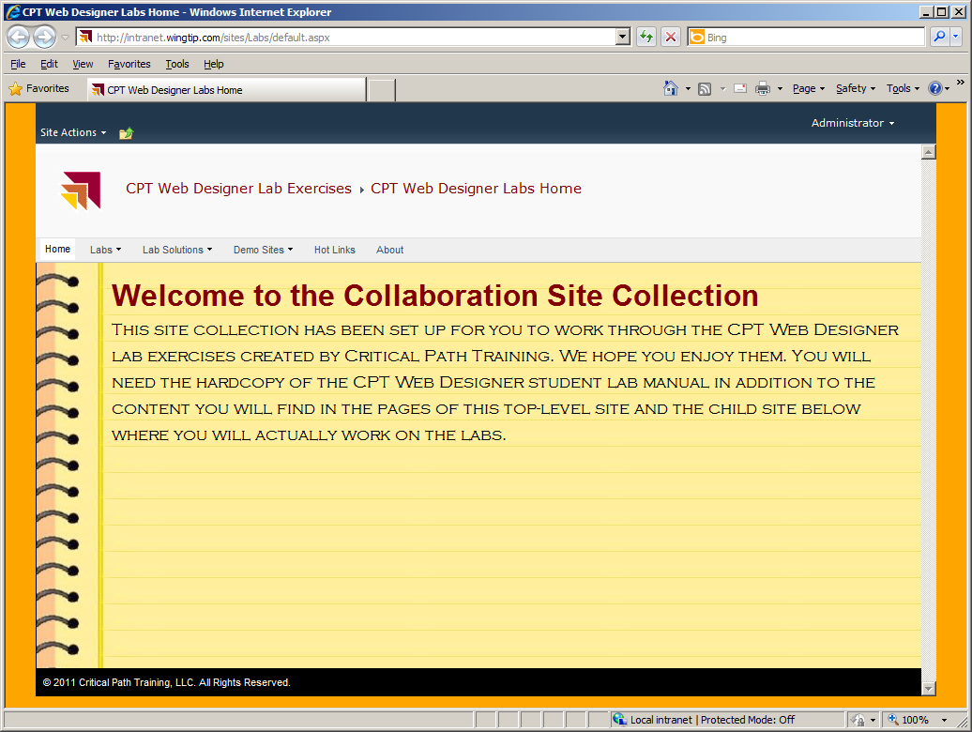

Exercise 2: Navigating with a Site Collection
In this very short exercise you will navigate around the Collaboration Site Collection to become accustom to getting around using SharePoint navigation controls.
- Use the drop down menu of the Top link bar to navigate to the site for lab exercises such as Lab01, Lab02 and Lab03.
- Navigate back to the top-level site using the dropdown breadcrumb menu. This will give you a sense of how you will navigate around this site collection to sites where you will do your lab work, as well as the site where you can see the lab exercise solutions.
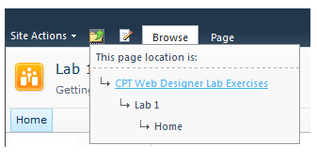
- Use the drop down menu of the Top link bar to navigate to the solutions for lab exercises such as Lab01, Lab02 and Lab03. This will give you familiarity with how to examine the sites where you can find a working solution to the lab exercises you'll work on throughout this course.
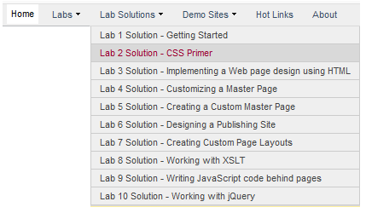

Exercise 3: Working with Wiki Pages
In this exercise you will work with wiki pages in the child site for Lab 01.
- Navigate to the home page of the Lab 1 child site, which is located at the following URL:
http://[[COLLAB-SITE]]/Lab01/SitesPages/Home.aspx.
- While on the home page of the Lab01 site, drop down the Site Actions menu and click the Edit Page menu command to take the current page into Edit Mode.
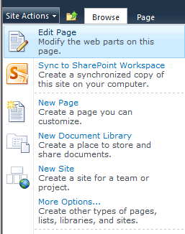
- Once you enter Edit Mode on the Home page, your first task is to modify the existing content. Start by changing the Text Layout of the page to One Column layout.
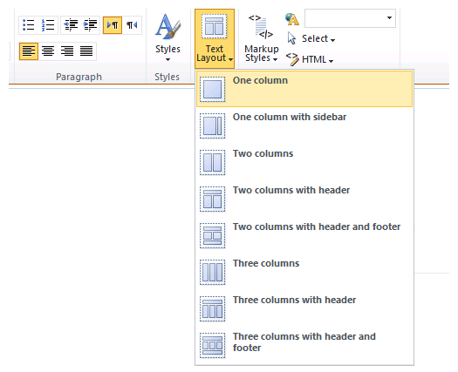
- Once you have changed the page to a single column layout, select and delete all the text under the title which reads "Welcome to your site!"
- Change the text of the title from "Welcome to your site!" to "Wingtip Sales Site". Use the text formatting buttons in the ribbon to give your new text a font with a size and a color to your liking.
- Now change the column layout of the page from the One Column layout to the Two columns with header layout. Make sure your title is in the header section. If it is not there after changing the layout, you can select the text of the title, and drag and drop it into the header section.
- Place your cursor in the left section and add a title of Wingtip Toy Planes. Once you have entered the text, select the text using the mouse and then use the Markup Styles drop down menu on the ribbon to change the style of the text to Heading 1.
- Add a little text under the title and use the Markup Styles drop down menu to change this text to the Paragraph style. You can be creative and think up what text to add or just add something such as "At Wingtip Toys, we are very proud of our extensive line of toy trains for the hobby enthusiast."
- Now it’s time to add a photo to the page. Place your cursor at the bottom of the left section under the text you added in the past step. Using the ribbon, select the Edit Tools > Insert. You should now see the Picture drop down menu.
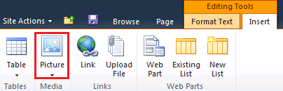
- Drop down the Picture menu and click the From Computer menu command. This will display the Select Picture dialog, which allows you to select an image file from your local computer's file system.
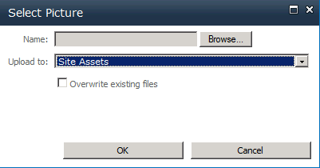
- Note that the Add Picture dialog will allow you to select a graphic image that will be automatically uploaded and stored in a special document library named Site Assets. Click the Browse button of the Add Picture dialog, and navigate to and select the image at the following location:
C:\Student\Labs\Lab01_GettingStarted\train1.bmp
- Click the Save button in the next dialog.
- The left column section should look like the screenshot below. Note that when the image is selected, it displays resizing handles. Resize the image to make it a little smaller.
- Now it's time to add some content to the right column using the exact same steps you used to add content to the left column. First, add a title of Wingtip Toy Planes and then add some text below it. Next, add a second picture to the page by adding the following photo image to the bottom of the right section.
C:\Student\Labs\Lab01_GettingStarted\plane1.bmp
- At this point, your page should look like the screenshot below.
- Now that you have made some content changes to the home page, save your work using the ribbon by selecting Editing Tools » Format Text » Save & Close. Alternatively, you could use the small Save button next to the Browse tab.
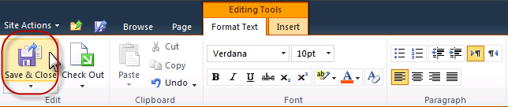

Exercise 4: Adding New List Items using Dialogs
In this exercise you will create a new list and add a few new list items. The main purpose of this exercise is for you to experience using the new dialogs that are part of the standard SharePoint 2010 user interface.
- Make sure you are still in the Lab01 site. Drop down the Site Actions menu and see what menu commands are available. Click on the menu command titled More Options… to navigate to the Create page. In the Filter By section on the left side of the Create page, select Lists. Select a list type of Tasks and enter a new list name of Tasks as shown below. Click the Create button to create the new list.
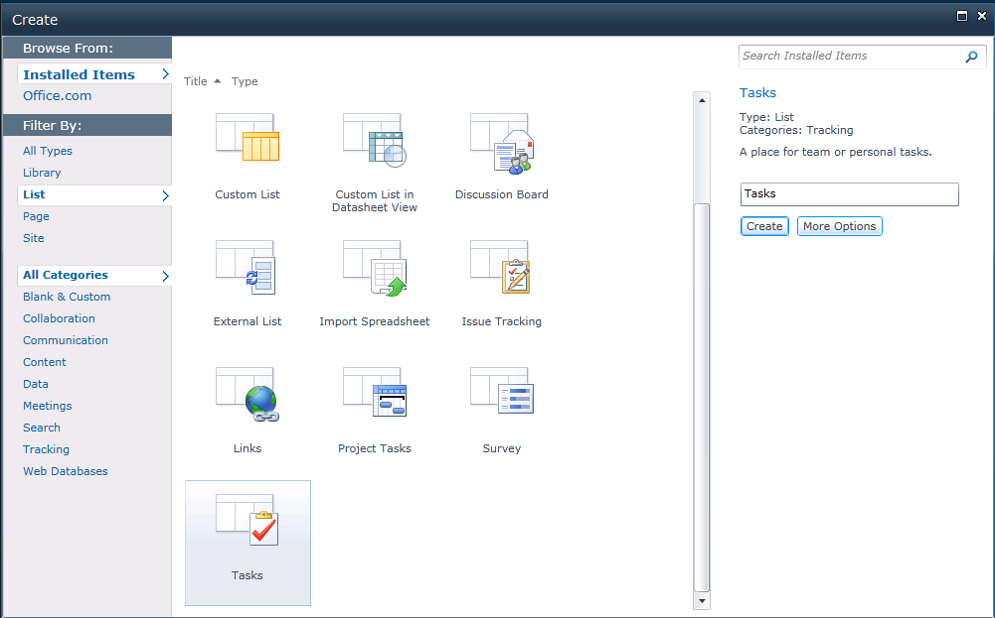
- Now it is time to add a new task item. Make sure you are at the All Items view of the new Tasks list. If you are not currently on that page, click on the Tasks link in the Lists section of the Quick Launch bar to navigate to the Tasks list. You should observe that there are no existing task items in this list. You should also observe the Task list has an associated server-side ribbon with a set of tabs including Browse, Items and List. Click on each of these tabs to see how the ribbon changes to display a contextual set of controls for a given set of tasks.
- Click on the Items tab of the Task list and then drop down the New Item menu and select Task. This action will display an input form for you to enter the data for a new task item. The next step will provide you with the data for the new task. At this point it is important for you to observe that the new SharePoint 2010 user interface experience is allowing you to add and edit task items without making the user endure HTTP post backs as was required in the previous version of SharePoint.
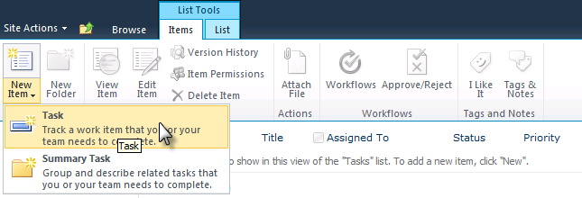
- Fill out the form for the new task using the following data:
Title: Learn how CSS works in SharePoint
Predecessors: none
Priority: (1) High
Status: In Progress
Complete: 2%
Assigned To: [[AD-DOMAIN]]\[USER-NAME]
Description: Start learning how to design branded solutions
Start Date: [enter today's date]
Due Date: [enter tomorrow's date]
- Create a second new task using the following data:
Title: Learn to create custom master pages for SharePoint 2010
Predecessors: Learn how CSS works in SharePoint
Priority: (1) High
Status: Not Started
Complete: 0%
Assigned To: [[AD-DOMAIN]]\[USER-NAME]
Description: Begin implementing branding solutions on SharePoint 2010
Start Date: [enter today's date]
Due Date: [enter the day after today's date]
- Once you have entered the two tasks from the previous steps, experiment with the list view by hovering over individual items. Note that each item highlights as you hover over it and the UI gives you the ability to select it. Use the Edit Control Block (ECB) menu (the standard SharePoint item-hover menu) to go into edit mode for one of the tasks you have created as shown below. Make a simple edit to the task and save it to observe the in-place editing behavior.

